DATA FRAME OF WEATHER MONITORING

START

~DEV_ID,TIME_INTERVAL,HUMIDITY, TEMPERATURE,RAIN(0/1),RAIN_VALUE(174 –thershold),COUNTER,RPM,M/S,KM/H,CRC_DATA **/**

END

Example:

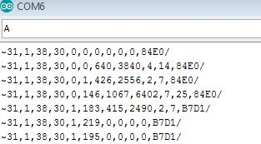

Command “**A**” in Serial Monitor give Instant data .

*Timer_Delay Varies from 10secs to 10 mins.

*By Default delay is 10 secs.

Explanation of DataFrame:

* **DEV_ID -** Represents device number which is used to identify .
* **TIME_INTERVAL -** Data will be displayed in Serial monitor every 10secs. We can vary the time interval using potentiometer 10 secs to 10 mins.

**\***Value 1 denotes 10 secs delay

**\***Value 3denotes 30secs delay

**\***Value 6 denotes 1 mins delay

**\*** Value 30 denotes 5 mins delay

* Value 60 denotes 10 mins delay

* **HUMIDITY -**  the amount of mositure present in the air.

**\*** Relative humidity above *70%* (and even lower at special conditions) may for normal living conditions cause condensation on cold surfaces - causing mold, corrosion and moisture related deterioration.

Too low relative humidity may cause problems with static electricity, cracking of paint and shrinkage of wood furniture and wood floors.

For humans relative humidity below *25%*feels uncomfortable dry. Relative humidity above *60%* feels uncomfortable wet. Human comfort requires humidity  to be in the range*25 - 60% RH*.

* **TEMPERATURE -** A measure of the warmth or coldness of an object or substance with reference to some standard value. There is certain temperature to cultivate crops .
* **RAIN(0/1) -**Here it displays zero or one.

*Zero(0) -No Rain

*One(1) -Itz raining

* **RAIN_VALUE -**It display value content of rain and meant for fix the threshold value (i.e 174)above 174 its shows 1 in **RAIN(0/1) ,**below 174 its shows 0 in **RAIN(0/1) .**
* **COUNTER -**One complete cycle of wind Sensor which equals to one pulse.
* **RPM -**Rotation Per Minute, gives value of rotation per minute.
* **M/S -**Meter per Second of wind Sensor.
* **KM/H -**Kilometer per Hour of wind Sensor.

**HARDWARE WIRING IMPLEMENTATION:**

**GND HUMDITY_TEMPERATURE**

**VCC WINDSensor**

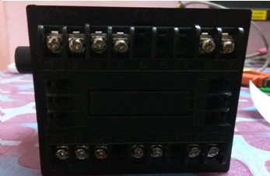 **RainSensor**

Pin Points :

1. ----> Vcc.
2. -----> Gnd.
3. -----> Humidity_Temperature.
4. ----->Wind Sensor.
5. ----->Rain sensor.
6. ----->Rain sensor.

**Humidity _Temperature:(3 wires)**

**\***Red

*Black

*Brown

Red should connect in VCC(1)

Black should connect in GND(2)

Brown should connect in Humidity_Temperature (3)

**Wind Sensor :(3 Wires)**

**\***Green

*Orange

*Yellow

Green should connect in VCC(1)

Orange should connect in GND(2)

Yellow should connect in Wind Sensor(4)

**RAINFALL SENSOR : (2 Wires)**

**\***Blue

*Violet

There is no polarity , we can connect any 2 wire in 7 and 8 pin .